**Requirements.**

1. What is the overall goal of your website?

The goal of this website is to bring relevant sales and deals that are aimed at students to them directly.

1. What are the functional requirements for your site? What will the site **do**?

My website will do a number of things like; link to all websites that are having sales inform people on where to go out for a drink on a budget. Deals on food whether it’s in a restaurant or even the local Dunnes Stores. Links to reduced of clearance stock of retail stores.

1. What are the non-functional requirements of your site? Do you have a preference for the look and feel of the site

We want the site to be different in both look and content. The website will have a responsive design to ensure the highest quality. The site will be interconnected with social media. I want to look informal, like it was built by a 19 year old. By college students for college students.

**Wireframe.**

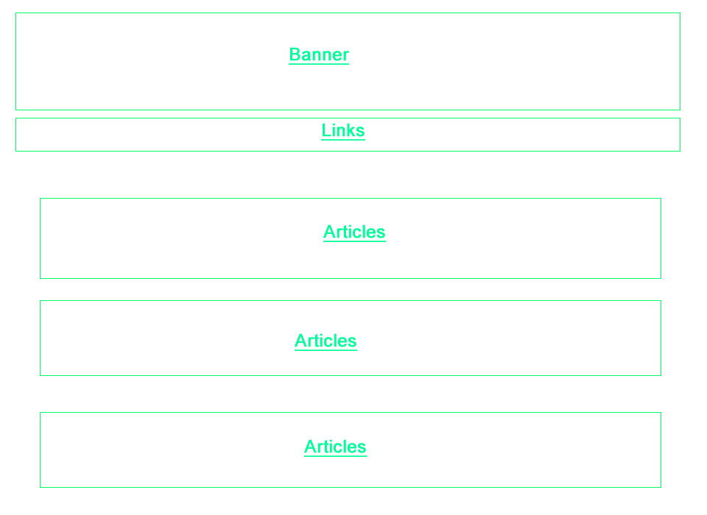

Designed with fireworks.